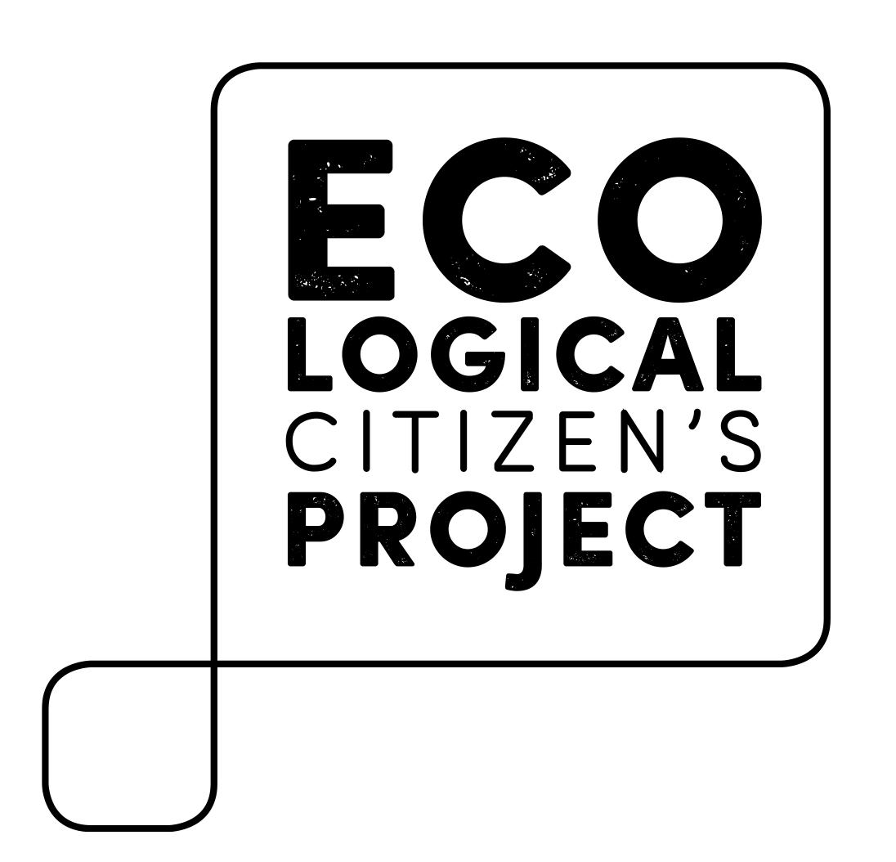

Planning Your Campaign

Before you begin, we hope you’ll remember two things: (1) If you can get your campus to adopt this demand, you can have a real impact on improving the environment and (2) We’ll only build a real sustainability movement if we’re willing to ask the powers that be for change. Good luck!

While any new campaign will be different, we thought we’d give you an overview of our campaign’s action steps:

- It starts with obtaining the amount of lbs. of beef currently served on your campus. This will help you determine the impact you can have and build your argument for change. The first place to go is your school’s “Food Service Provider”, often a large corporation that serves hundreds of cafeterias. They will have this information by the month, but may be reluctant to give it up. Be persistent – your tuition dollars pay for their contract!

- Plug your school’s lbs. of beef into our “Beef Impact Calculator” and create your own Issue Brief.

- Contact other student organizations or clubs at your school, brief them on the campaign and the impact it can have, and ask them if they will support the campaign.

- Schedule a meeting with the person on campus that has the authority to say “yes” to the campaign’s demand to reduce beef consumption by 50%. Most often, this will likely be your college or university’s President or Chancellor. In your request for the meeting, include the issue brief and the names of the student organizations (if any) in support of the campaign.

- Make your argument to the decision-maker and be sure to ask them clearly: “Will you support our campaign to reduce beef served on campus by 50% in order to save money, reduce environmental damage, and improve the health of the student body.” Let them know that you’ll be writing down their answer as a quote to report back to other student groups.

- Report back the results of the meeting to your school’s student groups and post an update on the Half Calf Campaign facebook page to let the movement know if we’ve just won more change. Make it fun – send a selfie with the decision-maker along with the quote!

